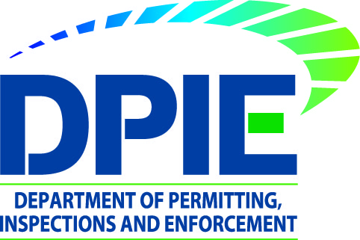
Pre-Construction Meetings Prior to Grading and Street Construction Permit Issuance

Effective August 1st, 2020, DPIE will require that permit applicants submit evidence of a completed pre-construction meeting prior to issuance of site development rough grading, fine grading and street construction permits. DPIE is re-instituting this procedure, due to numerous permit projects not complying with requirements to schedule a pre-construction meeting as the first step in site construction. Please note the following:

- Pre-Construction Meetings shall be scheduled after issuance of Green Stamp Final Erosion/Sediment Control Plans and Approved Type II Tree Conservation Plans (or Tree Conservation Exemptions).

- Permittee shall bring the Green Stamp Final Erosion/Sediment Control Plan and Approved Type II Tree Conservation Plan to the preconstruction meeting.

- Pre-Construction Meetings can be scheduled by phone by calling the DPIE Chief Site Road Inspector listed below:

North District Scottie Mauney 240 508 9877
South District Joe Brown 240 508 9865
Central District Graham Baldwin 240 508 9711

- Permittee shall upload the preconstruction meeting report into the eplan permit case, prior to permit issuance.

Date of Notice: July 8, 2020

